COMP 202 Lecture Notes (pre-semester)

Computers run by on/ off code. Electrical on/off switches denoted by 1 and 0.

**Binary**:

Instead of base 10 counting, we have base 2. Ex. 110=12

310=112

Where instead of having 0-9 digits you only have 0-1, and instead of having a 10n system you have 2n

Powers of 2: 0, 2, 4, 8, 16, 32, 64, 128, 256, 1024, 2048…..

Examples of binary: 53=110101

12=1100

Letters and symbols can be represented as numbers: ASCII:

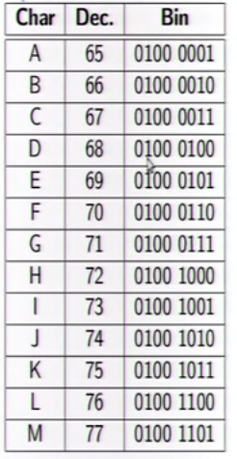

**How does programming work?**

We use algorithms that lets the computer solve problems.

We write these algorithms in a human-like language (JavaScript). These must then be compiled by a compiler. It turns the Java into a numerical code called Java bytecode which is more “computer-like”

**Steps to Programming in Java**

1. Write a program and save it
2. Compile the program (javac) – the compile button in Dr Java
3. Run the program (java) – the run button in Dr Java

**Steps to Programming IRL**

1. Deconstruct the problem you’re trying to solve
2. Plan the solution
3. Write a program that implements your solution
4. Compile the program
5. Fix the errors
6. Run the program
7. Realize it doesn’t work and go back to step one.

**The Class**

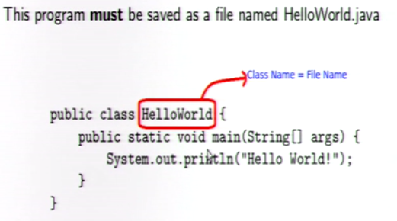

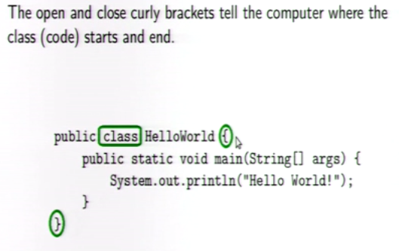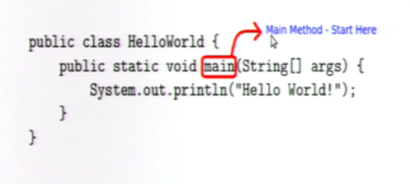

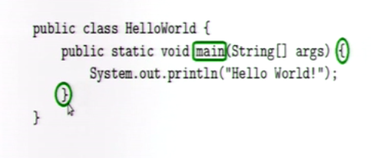

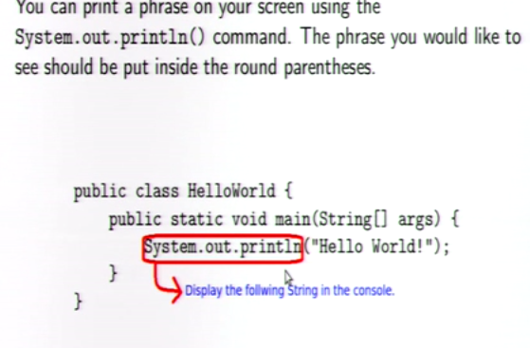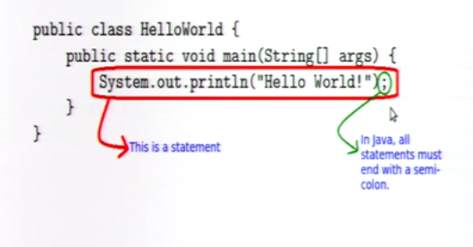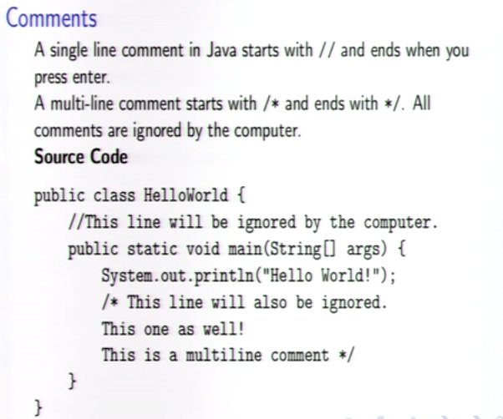

**Types of code:**

- code that defines where a block starts and ends. These either end with an open curly bracket or the whole line is just a single closed curly bracket.

This is the code starting the block {

this is the block it will end in a curly bracket

}

-code that do. (statements) end in semi-colon.

-code that don’t do. (comments) start with // for single line, or /* for multi-line, and ends with*/

**Code Structure:**

In order to make your code more readable there are rules. (when to have new lines, when to indent etc)

-When to go to a new line: When you have an open curly bracket { , a close curly bracket }, or a statement ending in a semi-colon. (with a few exceptions)

-When to indent: when you start a new block (have an open curly bracket) all subsequent lines should be indented. When you end the block, all subsequent lines should be un-indented. Basically just line up the closed bracket with the thing it corresponds to.

**Statements:**

-A method in Java can have as many statements as you want

-It will execute them from top to bottom.

**Printing to screen and packages:**

-println() (in System.out.println()) is a method that was written by someone else.

-A method is a chunk of code that performs a specific task

-the println() method was put in a package so that we can use it!

-A package is a collection of code that someone else wrote that they allow other people to use

-It’s just so that nobody has to re-invent the wheel every time they want to drive ;)

-If you do not want to skip a line after printing, use the System.out.print() method instead

**Displaying Numbers:**

-Using the same method as before, but we don’t need the double quotes.

-Note that if you try to display a String without the double quotes you will get an error.

**Evaluation:**

-Anything inside the brackets of a method ie: System.out.println(this thing here) gets evaluated before its printed to the screen.

**String Concatenation:**

-you can combine two Strings together using the + operator.

Example: System.out.println(“Hello” + ”World”); would print the two words on the same line, same as if you had (“Hello World”);

**The + Operator:**

**-**The + operator can concatenate strings, or can act as an arithmetic operator 9+20=29

**Displaying numbers**

Code A:

public class Mystery{

public static void main(String [] args){

System.out.println(4+5)

}

}

Code B:

public class Mystery{

public static void main(String [] args){

System.out.println(“4”+”5”);

}

}

Code A will print 9, and Code B will print45.

**A useful program!**

Write a program that converts 145lbs to kg and displays the result. Note 1lb=0.453kg

**Another Program**

Write a program that converts 85 degrees Fahrenheit to Celsius and displays the results.

Note: (F-32)*5/9=C

**Variables**

-A variable is a place in computer memory where you can store data and access later on.

-Variable must have a name, so that you and the computer know where it is.

-It must have a type, so that the computer knows how much memory to save.

-Useful for readability and generalization, and temporary storage for partial results.

Life of a variable:

-Declaration: Giving it a name and type. (int myNumber;)

Type of that variable is int. short for integer.

Name is “myNumber” can be anything just make it up.

Note that this is a statement and ends in ;

-Initialization: You can now set the initial value (myNumber=56;)

Note you are not repeating the type.

-Manipulation (using variables)

**The assignment operation**

* The = sign is not equal like in math. It’s an assignment operator. It means “gets the value”.
* Whatever is on the right gets evaluated, and the value is assigned to what is on the left.

potato=10+6 assigns the value of 16 to the variable called potato

* To save space, you can declare and initialize on the same line. (Int myNumber = 56;)

**Compare these two programs:** 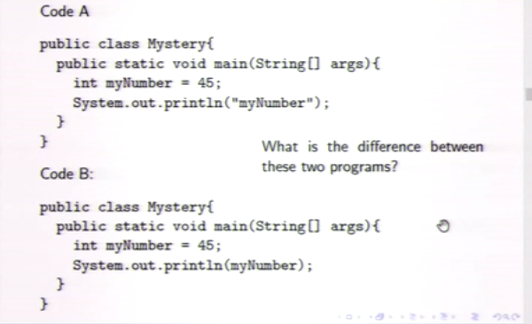

Difference is the double quotes around myNumber. In code A will just print the number wheras code B will print the number 45

**Variable Naming**

-name your variable something descriptive of its purpose or contents.

-if the variable is one word, then all letters should be lowercase

-if they are more than one word, then the first word should be all lowercase and the all next words should have first letter capitalized. amountOfMilk

**Accessing Data from a Variable**

-what if you put a variable on the right hand side of the = operator?

Int x = 5;

x= x+1;

here, the first line declares x to be 5, then the next line evaluates as x being 5 on the right hand side, so x (on the left) is 6.

**Multiple Variables**

-What happens when we put a variable on both sides of the =

int x = 5;

int y = 8;

x = y;

here the right is evaluated, and the value 8 is assigned to x. So they are now both 8. However, if you had

y = x;

here they are both 5.

* Another example: int x = 5;

int y = 8;

x = y;

y = y + 1;

so now x is 8, y is 9.

**Ex.** int x = 45;

int y=x;

y=12;

x=x+1;

What are the values of x and y? x=46, y=12

**Variable Types:**

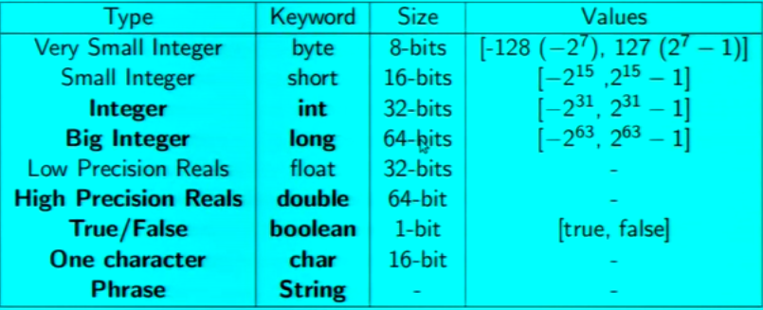

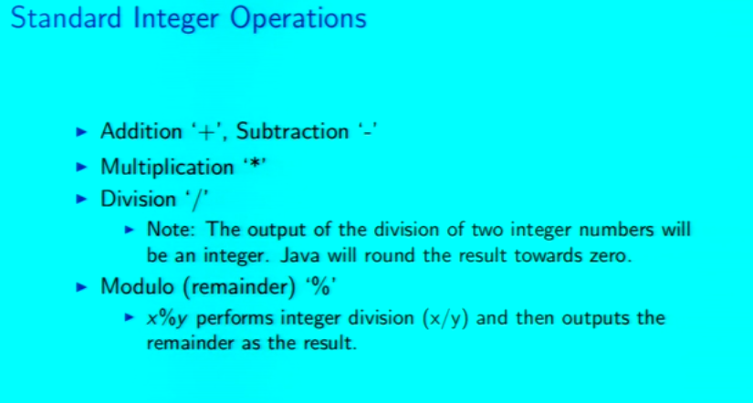

**Overflow and Underflow**

Max cash on runescape is 2147483647 because this is the biggest number an integer variable can be.

You can access it using the Integer.MAX_VALUE command.

Why is it the max number?

An integer has 32 bits. 31 are used to store the digits, and one for the sign (+/-) (positive is 0, negative is 1)

Note that a bit is a digit in binary, (1/0),

**Typecasting**

You can convert back and forth between integers and decimals using something like this:

int x1= 5;

double x2=6.58;

int x3 = (int) x2;

double x4 = (double) x1;

Now, x1 = 5, x2=6.58, x3=6, x4=5.000

**Math library:**

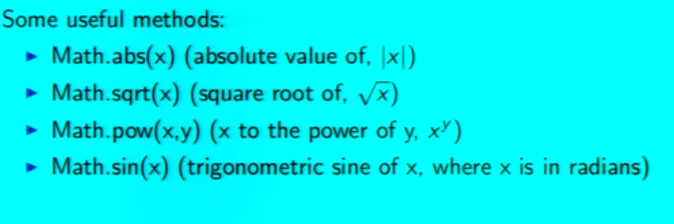

These are all in the math library database that comes installed with java

**Strings:**

Strings are a variable type for phrases. We can declare a String in the same way as other variables.

String s = “this is a string” if you want to have a newline character use \n

You cannot use a cast when converting from a String.

To convert from an int/double to a String, just concatenate the number with the empty string (“”)

String s = “ “ + 4;

To convert from String to an int, use :

int x = Integer.parseInt(“4”);

or String s = “56”;

int y= Integer.parseInt(s);

**Expressions:**

-An expression in Java is something that gets evaluated to a value

-That value will have a specific type.

-Literal values: 4, “Hello”, -12.345

-Variables: myNumber, x, s

-Returned method values: Math.sqrt(4), Math.pow(2,3)

-Combinations of expressions

-What value is assigned to x?

int x = ½ + ½ ;

x=0 , because these are ints, ½ is rounded down to 0, so 0 + 0 = 0.

-How about now?

int x = 0.5 + 0.5;

x= nothing, there is a compile time error! Because when you add doubles, you get a double, but our variable is trying to be stored as an int, so it doesn’t work.

-How about now?

double x = ½ + ½;

x = 0.0 because we’re still doing integer division on the right, but the result is stored as a doubl

-Now?

double x = (double) ½ + ½ ;

x=0.5, the cast happens before any arithmetic. So the first one becomes 0.5, then the second one is 0, so 0.5 + 0 = 0.5

When you use a method, you have to make sure the expression inside the parentheses evaluates to the correct type.

Which of the statements work?

double x = Math.sqrt(9.0);

double y= Math.sqrt(“puppies”);

double z = Math.sqrt(“4”);

Only the first, because it’s the only one that has a number, the others are taking the square roots of strings which doesn’t work.

Which of these work ?

String s = Math.pow(3,5);

double x = Math.pow(2,3);

String s = System.out.println(“Hello”);

Only the second one, because Math.pow stores as doubles, and the only way to store a double as a string is to cast it as a string. String s = “” + Math.pow(2,3); would work.

The last one doesn’t work because System.out.println() evaluates to nothing. (void)

**Methods in methods:**

As long as the types match, you can put as many methods inside others as you want.

Which statements work?

Double z = Math.pow(Math.sqrt(Math.sqrt(3)));

Math.tan(Math.sin(Math.cos(3)));

String s = System.out.println(Math.sin(Math.cos(Math.abs(-4)+3)*2));

The last one doesn’t work because this method doesn’t evaluate to anything

**String[] args**

This is called the command arguments

It allows for the user to set values for variables, instead of the programmer needing to do in the java file

Args is just a variable name, used by convention

It’s a String[] type variable, (a list of strings)

So if you want to do arithmetic with them, you have to change them to int or double by parsing them

**Random numbers:**

The Math.random() method generates random numbers between 0 and 1

So to make random numbers between 0 and x, you’d multiply x by Math.random().

**Methods:**

Method is a named block of code that performs a task. All method descriptions must be written inside a class, and a method description cannot be inside another method description.

So far we’ve only writing in the main method, and inside we’ve only *called* other methods. You can call other methods, but cannot describe within a method.

Types of methods:

-Some methods don’t evaluate to anything but do take input ie. System.out.println();

-Some methods do not take input, but return a result ie. Math.random();

-Some methods take input and return a result ie double x = Math.pow();

-Some methods do not take input and do not return anything

Ie: public static void myMethod(){

//do something

* Void means it doesn’t return a value
* Having nothing between the () means it does not accept input.

Writing your own method:

Write a method that takes no input, returns nothing, and prints a postal address.

1234 Snail Lane,

The Shire, Eriador

Kingdom of Arnor

Middle Earth.

Call this method from the main method. Both of these should be in the same class.

You can write your other methods before and/or after he main method, its good to put it at the top or bottom of your code.

**Scope:** A variable only exists within the method in which it is declared, you cannot use it anywhere else.

Write several methods that have a variable called x. Each method should assign x a different value, and then print the value. Call these methods from main.

**Methods that take input:**

The method below has one input parameter, an integer variable named x.

The variable x exists only in this method, this method does not return anything

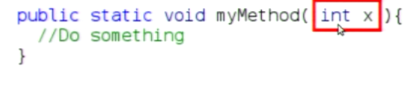

To call this method you’d write something like : myMethod(5);

Example: Write a method that takes input as a number corresponding to the radius of a sphere, compute and print the volume and surface area of the sphere.

You can put as many input parameters as you want.

Ex: 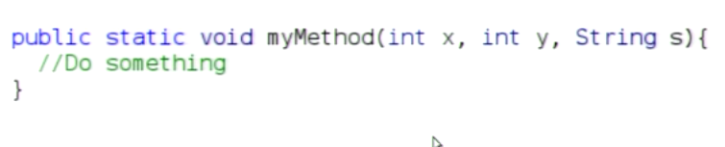

**Methods that return something:**

The method below has no input parameters and it returns an integer type value. The return type must be specified in the header. Methods can return at *mos*t one value. 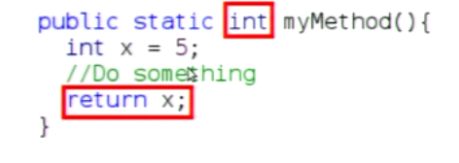

**Methods that do both:**

If you write something like: public static double myMethod(int x, int y){

Double n = 0.0;

Return n;

**Properties of methods:**

Like functions in math, methods can take more than one input parameter. F(x), f(x,y), f(x,y,z). Methods can return at most one value.

**Booleans:**

Are either true or false, they can be combined using the AND (&&), OR (||), and NOT(!) operators.

NOT: Basically just flips the definition of your variable. If a is true, then !a is false.

AND: a && b evaluates to true if and only if both a and b are true.

OR: a || b evaluates to true if at least one of a and b are true.

**Comparing values:**

X==Y Do x and y have the same value?

X!=Y Are x and y different?

x>y is x greater than y, etc.

**Why Booleans?**

Sometimes we want certain things to happen only if a certain set of conditions are met.

**If/else Blocks**

We can condition the execution of blocks of code on the evaluation of Boolean expressions.

When the condition expression evaluates to true, the following block will execute

If we would like to do something when a condition is true, and something else when its false, you’d use an else block.

if (condition){code here}

else){code here}

**If/else if/else blocks**

If we want to do something if neither condition is true, then we can use if else if else blocks. 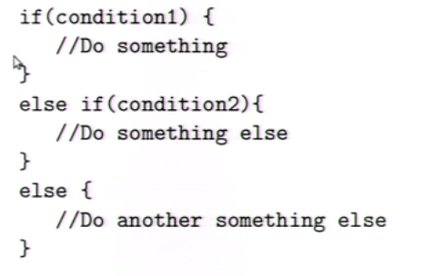

**Short Circuiting:**

10/5 <1 && 10/0<1 These two things are not equivalent. Because of short circuiting

10/0<1 && 10/5<5 The first, reading left to right, it will first see that 10/5<1 is false, so it will return false for the whole thing.

The second, it will get an error, because 10/0 is undefined

This works for other Booleans too, for &&, if the left is false, all is false.

For || if the left is true, then the right is skipped, and all is true

This can make your code more efficient, say you have a slow method and a fast method, then you’d put the fast one in a position where the slow one only runs if absolutely necessary.

Can be useful to avoid errors, such as dividing by zero.

**Miscellaneous Math Ops:**

Pre-increment ++x (x = x +1)

Pre decrement --x(x=x-1)

Post increment x++(x = x+1)

Post-decrement x-- (x=x-1)

X+ =9 (x= x+9)

X-=7(x=x-7)

X*=3(x=x*3)

x/=4(x=x/4)

x%=2(x=x%2)

**While Loops**

A while loop will execute forever, while a condition is true

Ex. 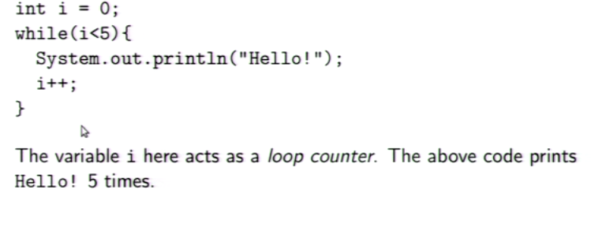

**For loops:**

A *for* loop is a while loop with a counter, the two types of loops are equivalent, and you should use whichever seems more appropriate.

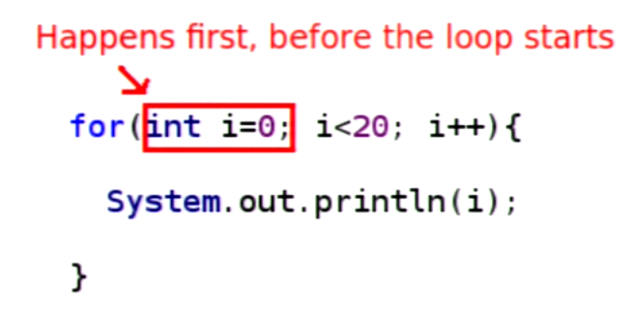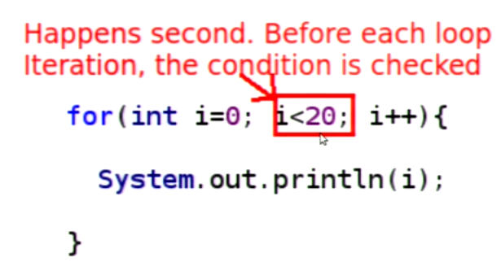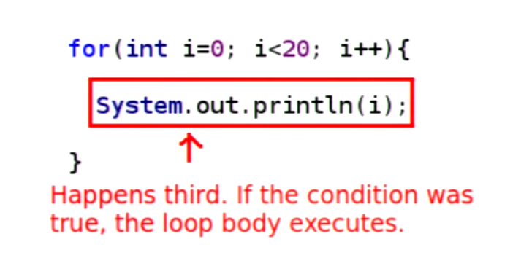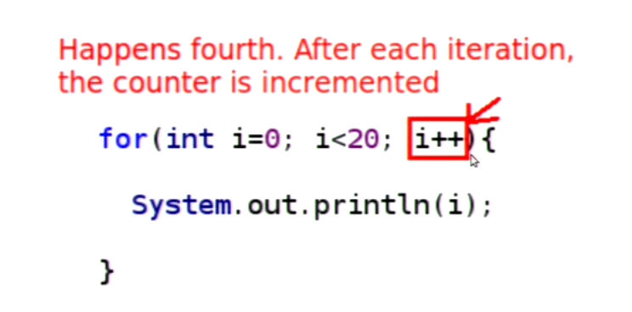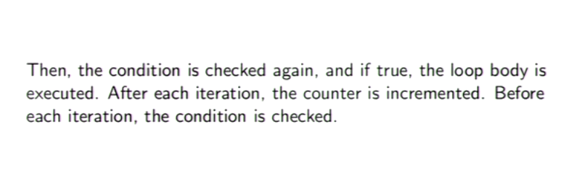

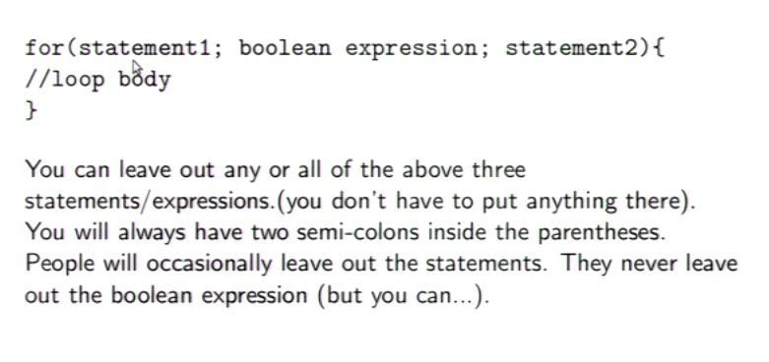

**Useful Loop keywords:**

Break: causes immediate exit from the innermost loop

Continue: keyword causes the program to skip to the next iteration of the loop

**Characters:**

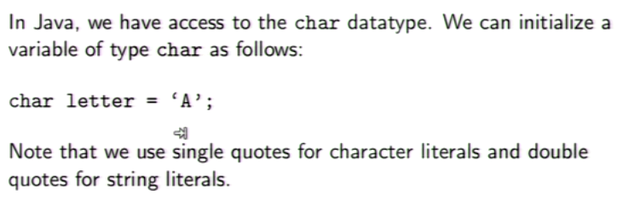

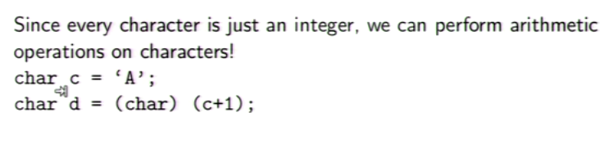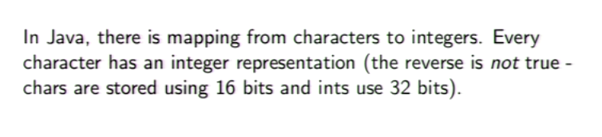

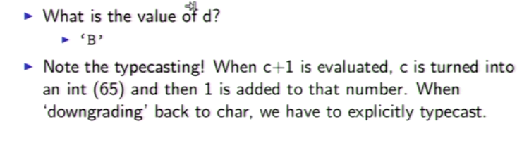

(use the ASCII table)

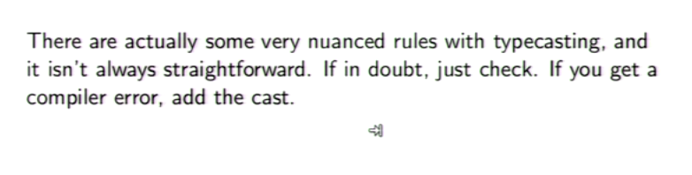

**Strings:**

Strings are just a list of chars

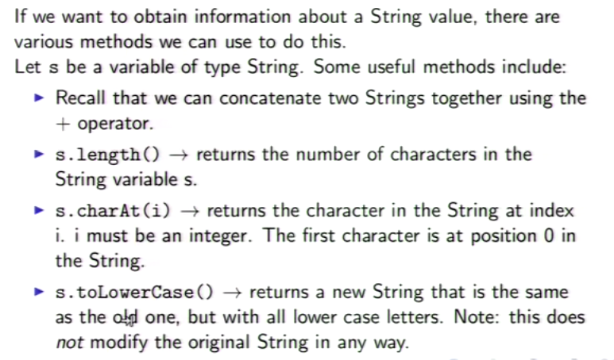

There are more, just look them up in the String API

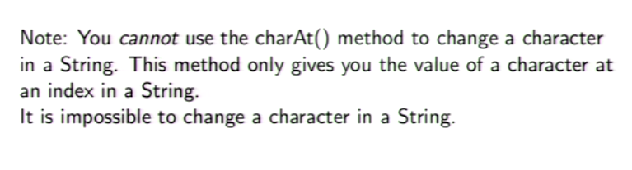

**Comparing Strings:**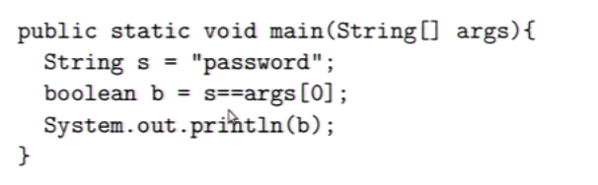

This will print false, because the == with strings asks a slightly different question than usual. Instead of asking if this list of characters is equal to this other one, it asks if this String variable is equal to this other String variable. Be careful!!!

Instead of ==, use: .equals() method

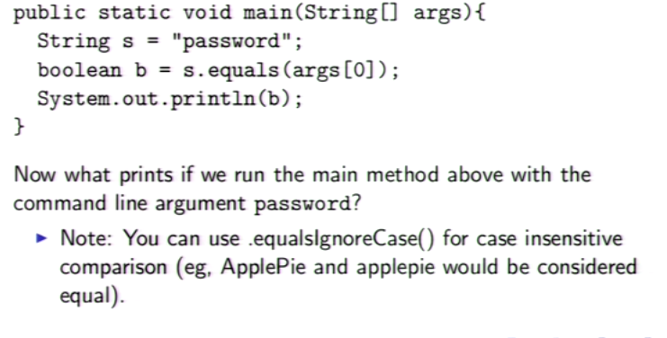

This will work.

Side note: this is because String is not a primitive type (primitive types start with lower case: int, double etc)

**Nested Loops:**

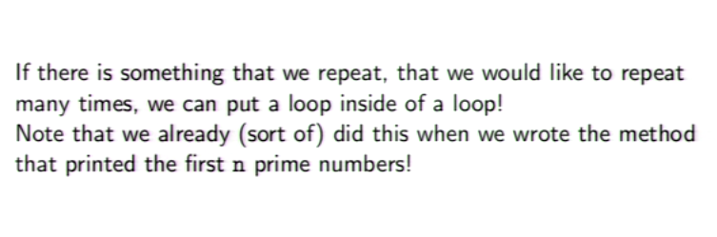

**Arrays:**

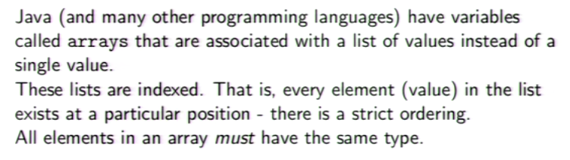

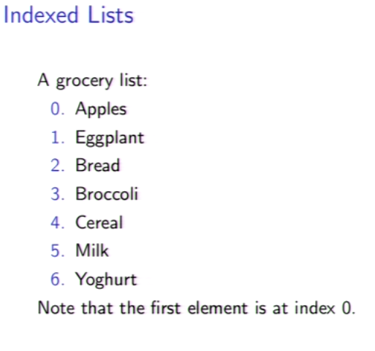

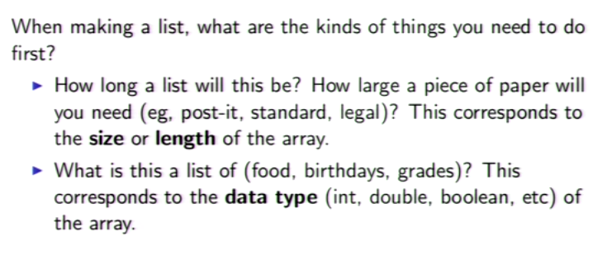

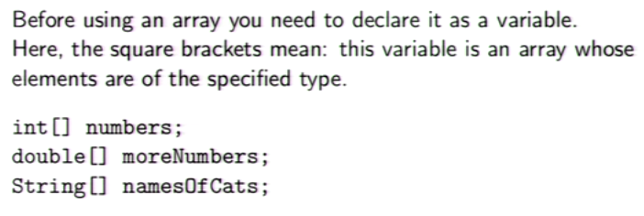

(We’ve been using arrays the whole time with the (String[] args) in our main method

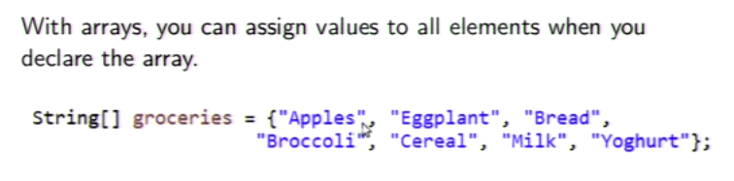

This is an array of String values of length 7.

What is the index of apples? What is the index of yogurt?

(0, 6): Remember that arrays (like loop counters) start at 0.

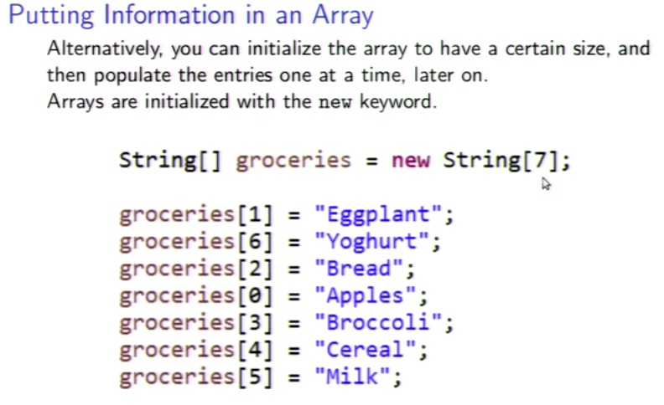

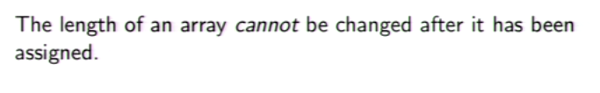

Note: The keyword new is used to initialize non-primitive types (reference types). While Strings are reference types, they are an exception to this rule

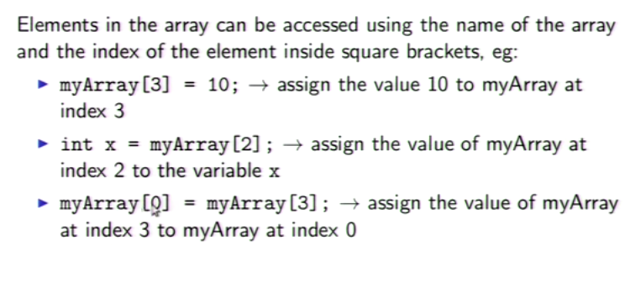

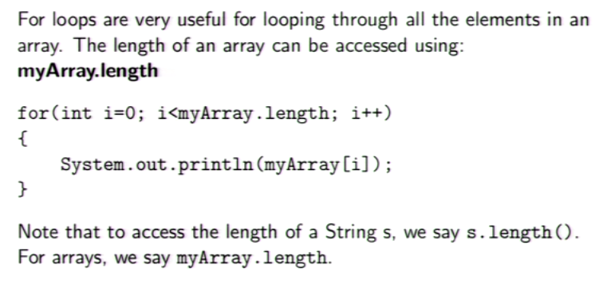

**Nested loop review:**

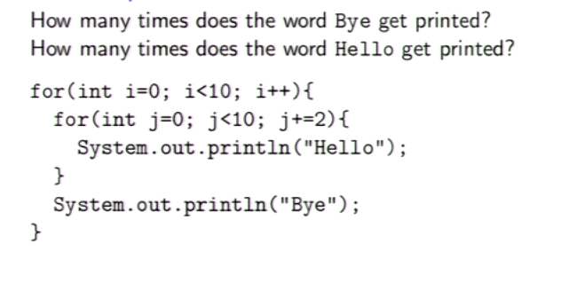

Outer loop = Bye = 10 times,

Inner loop= Hello=50 times(5 times for each bye, so 5x10=50)

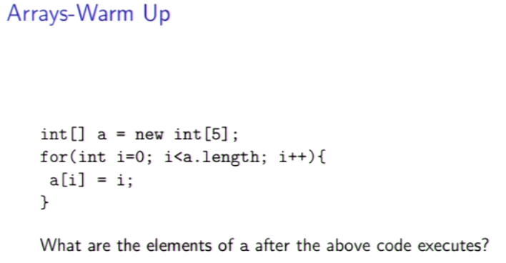

0,1,2,3,4.

Note: The 1st line is declaring the array, its telling the computer “save space for 5 integers” but not initializing the values.

Note: the 3rd line is assigning the values of the array, this is useful so you don’t have to manually type out each value.

Note: You can return an array.

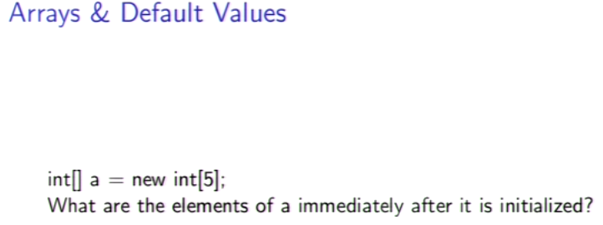

If you don’t input elements in an array, Java will assign default values to each position.

Numerical arrays: 0

String arrays: null

Char arrays: ASCII value 0

Boolean arrays: false

Note: This is a java-specific thing, when learning C++ or other languages be carefull

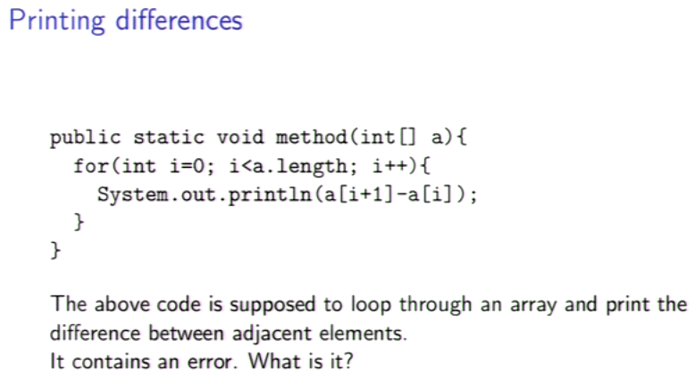

The i+1 wont work on the last value of i, because its one larger than the largest value.

You could fix it by setting i to start at 1, and have it be a[i]-a[i-1]

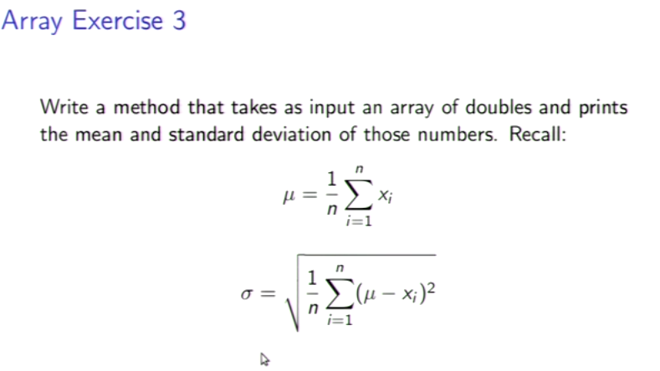

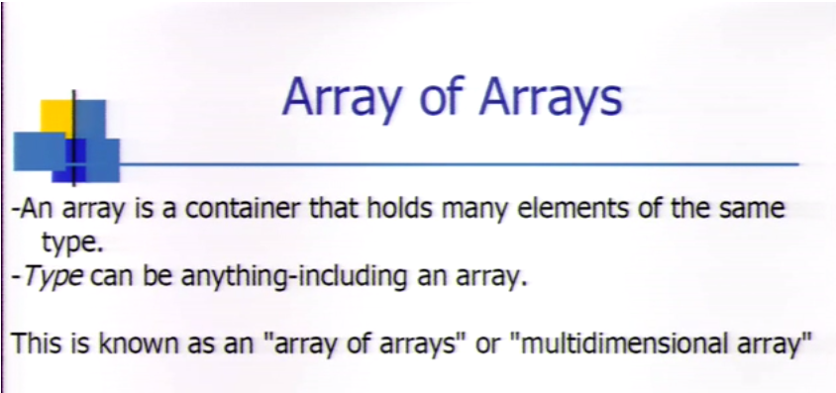

For these you would use two indexes. Int[][]. The first [] represents which array to use, the second [] represents a specific number within one of the arrays.

Array[0][10] gives the 11th number in the first array

Array[4][5] gives the 6th number in the 5th array

Note: In an array of arrays, a.length tells how many arrays are inside, NOT the number of numbers

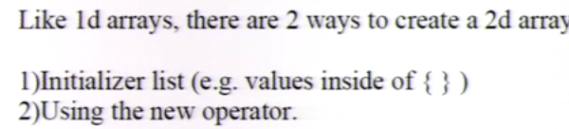

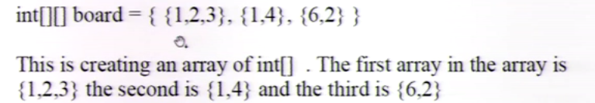

Note: ARRAYS STILL NEED TO BE THE SAME TYPE (ARRAY ITSELF IS NOT A TYPE) 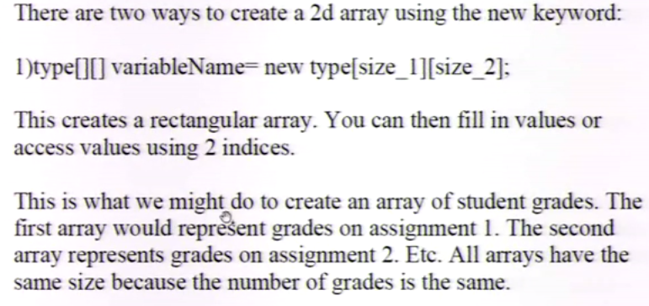

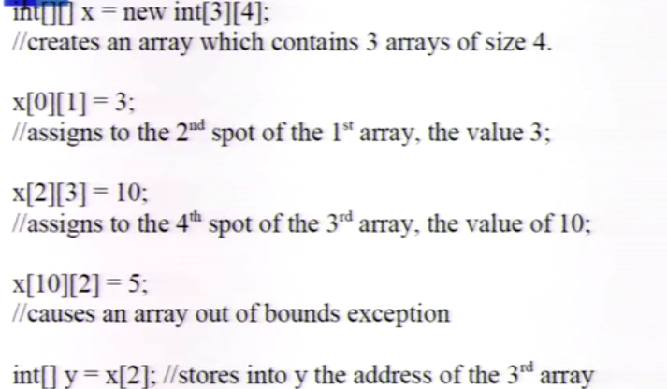

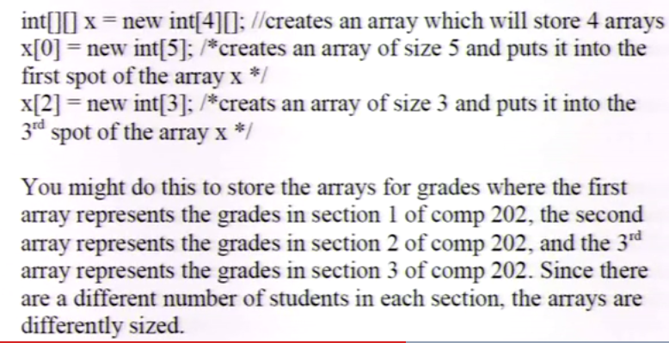**Jagged arrays:**

**Higher dimensional arrays:**

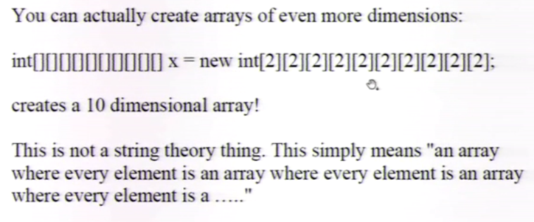

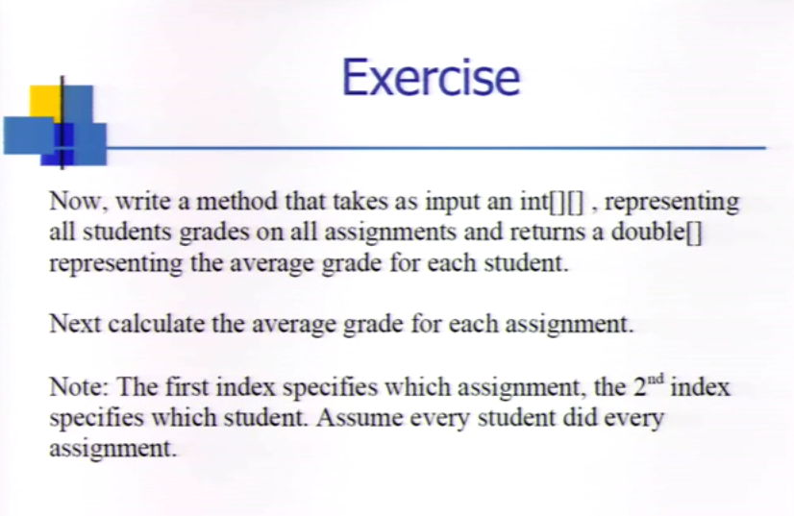

**What is all that gibberish when you try to directly print an array?**

Arrays, and all objects in Java are never stored directly into variables. They are accessed indirectly via reference variables.

So far, other than String, we’ve mostly been using primitive types. These are built directly into the language. So instead of the variable storing the info, it tells you where to find that info.

Primitive type:

If we write, int x=10; what we’re technically doing is:

1.) Creating a space in memory that will store an int.

2.) Specifying that whenever we use x, we want to access that location.

3.) Storing the value 10 into that location

Reference Type:

However, when we write, int[] x={10,3,5}; whats happening is:

1.) Creating a space in memory that stores the a*ddres*s of an int array.

2.) Specifying that whenever we use x later, we want to access that space in memory.

3.) Creating an array *somewhere else* in memory. That array will store the values 10,3 and 5, and have length of 3. That array must be located somewhere in memory. Call that address “a”.

4.) Setting the value of x to be “a”.(store into the space of memory reserved for the variable x, the value of “a”)

**Consequence of reference types:**

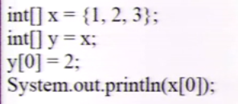

When int[]y=x; its only copying the address of x into int[] y, not the entire array. And so when you change y[0], you’re also changing x[0], so this will print 2.

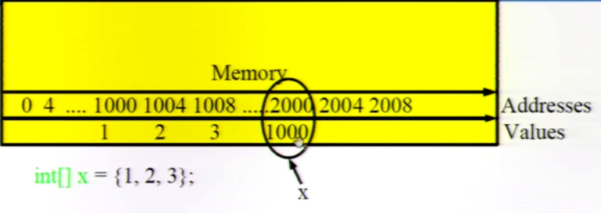

X is given value 1000 at address 2000, while the numbers within x are stored at 1000, 1004, 1008. Meanwhile, when you name int[] y = x, it assigns the same value 1000 as x, but it needs a new address. Now when you write y[0]=2, it will see y=1000, go to the address 1000, and update the value of the 1000th position thing to be 2 instead of 1. Then, when you go to print x[0], it will print the updated value of the 1000th position, which is now 2.

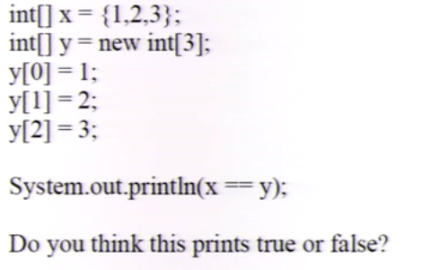

False! Because they are storing different addresses, because they are different arrays. 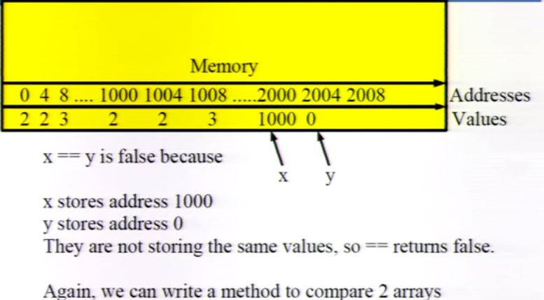

**Break in sequence:**

**The following are notes from the book:**

Think Java: How to Think Like a Computer Scientist

(This is the point where the book and the lectures “diverge”, so I’ll follow the book, and come back to the lectures later.)

What the book has covered so far*:*

-Ch2: Variables and Types (Basic operations)

-Ch3: Void methods (Print statements, what are methods)

-Ch4: Conditionals and recursion (calling a method on itself + Boolean expressions)

-Ch5: GridWorld case study pt1 (more confusing than useful at the moment)

-Ch6: Value methods (how to return values from a method and use it in another method)

-Ch7: Iteration and loops (while loops, nested loops, tables, local variables)

Note that it has not covered arrays yet, it will first introduce objects. Conversely, the lectures have covered arrays but not objects.

8.1 Characters:

-An object is a collection of related data that come with a set of methods.

-Strings are objects, they are an array of characters stored in an object

-The charAt(); method is invoked on a String object, where the index n is the argument.

8.2 Length:

-The .length method takes no arguments and returns an int.

-Note that if you want to do charAt(length) you must do charAt(length-1) because of the way the index is counted.

8.3 Traversal

- Traversal is the process of selecting each character in turn, doing some computations with each one until the last letter.

Example 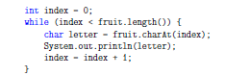

This loop traverses the string and prints each letter on its own line.

8.4 Run-time errors

-In Java, run-time errors are called exceptions

-These only occur once the program is run, it doesn’t show up during compilation.

-“*Throws* an exception” can be thought of as the program throwing a tantrum

8.5 Reading documentation

On the oracle website, you can find info about methods and libraries

It will tell you what it does, what it takes as parameters, what it returns, and throws.

8.6 The indexOf method

-indexOf is the opposite of charAt. It takes an character and returns the index instead of the other way around

-it fails if the character doesn’t appear in the string, and returns the value of -1.

-If something is there more than once, it returns the first one

-To find the others, theres another version of indexOf, that takes a second parameter that tells it where to start looking.

8.7 Looping and counting:

Example code:

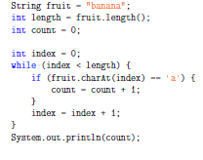

This code counts how many times the letter ‘a’ appears.

8.8 ++ and – operators:

-Already mentioned in lectures

8.9 Strings are immutable

-When you invoke something like toUpperCase on a String, you get a new String as a return value, since strings are immutable (cannot be mutated).

8.10 Strings are incomparable

-We cannot use == or > operators when comparing strings

-We must use .equals and .compareTo methods

-The syntax is kind of weird, you have to invoke a method on one of them, and pass the other as an argument.

- .equals returns true or false

-.compareTo returns the difference between the first characters in the strings that differ. If the strings are equal, it is 0. If the first string comes first in the alphabet then the difference is negative.

9 Mutable Objects

-Strings are objects, but they’re a special case because they are immutable, have no attributes, and do not need to use the new command to make one.

-Preface about Point and Rectangle: They are *not* graphical objects that appear on the screen, they are values that contain data just like ints and doubles, and are used to perform computations.

9.1 Packages

-Java libraries are divided into packages

-java.lang is one that is imported automatically that contains most of the classes we’ve used (Math, String).

-java.awt (Abstract Window Toolkit) is one that has classes for windows, buttons, graphics etc.

-To use a class defined in a different package, you have to import it.

-To get the Point and Rectangle objects, we need to import the AWT package like this:

import java.awt.Rectangle;

import java.awt.Point;

-These statements are outside the class.

9.2 Point objects

-A point is a set of coordinates (x,y) so two numbers that can be treated as a single object

-To create a new point you have to use new:

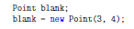

-The result of new is a reference to the new point, so blank contains a **reference** to the newly created object.

-The names x, y are the names of the **instance variables**

-Together, the variables, values and objects in a program is called the **state** . The state changes as the program runs.

9.3 Instance Variables

-The pieces of data that make up an object are called instance variables because each object, which is an instance of its type, has its own copy of the instance variables.

Clarification: 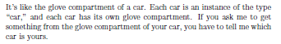

-So if you wnt to read a value from an instance variable you have to specify the object you want to get it from. Int x = blank.x;

9.4 Objects as parameters

-You can pass objects as parameters in the usual way

-If you try to print a Point, you’ll get java.awt.Point[x=3,y=4]

9.5 Rectangles

-Rectangles are similar to points, except that they have four instance variables: x,y,width,height.

9.6 Objects as return types

-You can write methods that return objects

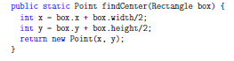-Example code:

This method takes as parameters a Rectangle, and returns a Point in the center of the Rectangle.

9.7 Objects are mutable

-You can change the contents of an object by making an assignment to one of the instance variables at any time.

-For example, you could move a rectangle by changing its x, and y values, but keep its size by not touching the width or height

-dx and dy are common variable names for changes to a variable

-Modifying objects by passing them as arguments to methods can be useful, but it can also make debugging more difficult because its not always clear which method invocations do or do not modify their arguments.

-Java has methods that operate on Points and Rectangles here :

http://download.oracle.com/javase/6/docs/

api/java/awt/Point.html

http://download.oracle.com/javase/6/

docs/api/java/awt/Rectangle.html.

9.8 Aliasing

-It is possible to have multiple variables that refer to the same object

-This is called aliasing (like when someone has two names (aliases))

-When two variables are aliased, and changes that affect one variable also affect the other

-This can make debugging difficult so it should be avoided whenever possible

-Handle with care

9.9 Null

-When you create an object variable, remember that you are creating a reference to an object. Until you make the variable point to an object, the variable is null.

-If you try to use a null object, Java throws a NullPointerException

-It is legal to pass a null object as an argument or receive one as a return value, however.

9.10 Garbage collection

-What happens when no variable refers to an object?

-Example :

The first line creates a new object and makes blank point to it. The second line changes blank so that it points to nothing.

-Basically the object ceases to exist

-It would waste space in memory, so as the program runs, it will look for stranded objects and reclaim them in a process called **garbage collection**

-It’s not super important, but it’s good to know what’s happening behind the scenes

9.11 Objects and primitives

-There are two types in Java, primitive types, and object types (reference types).

-primitives like int, double, boolean, start with lower case letter

-object types start with upper case; String, Point, Rectangle

-When you declare a primitive variable, it is given a storage space for a primitive value.

-When you declare an object variable howerver, you get a space for a reference to an object, to get space for the object itself, you must use *new*.

-If you don’t initialize a primitive type its given a default value depending on the type, objects type have default null.

-Primitive variables are well isolated in that there is nothing you can do in one method that will affect a variable in another method. Object variables can be tricky to work with because they are not isolated. If you pass a reference to an object as an argument, the method you invoke might modify the object.

-You cannot add a new primitive type to java, but you can create new object types!

~~~~~~~~~~~~~~~~~~~Detour~~~~~~~~~~~~~~~~~

Appendix A: Graphics

A.1 Java 2D Graphics

-There are several ways to create graphics in Java, the simplest is to use the java.awt.Graphics package

-Complete example:

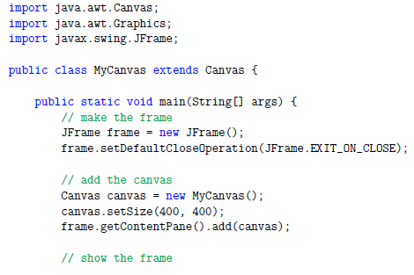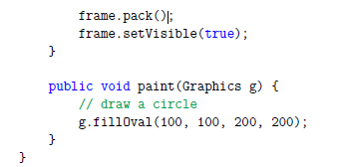

-The first lines import the classes needed from java.awt and javax.swing.

-We make a class called MyCanvas that extends Canvas, means that the MyCanvas object is a kind of Canvas that provides methods for drawing graphical objects.

-In main, we first create a JFrame, which is a window that can contain the canvas, buttons, menus, and other window components. Use a method that makes it exit when we close the window.

-Next we create MyCanvas object, set its width and height, add it to the frame, and display the frame on the screen

-Paint is a special method that gets invoked when MyCanvas needs to be drawn. If you run this code, it should display a black circle on a gray background.

A.2 Graphics Methods

-To draw on the Canvas you invoke methods on the Graphics object. The previous example uses fillOval. Other methods include drawLine, drawRect, etc. Documentation here:

http:

//download.oracle.com/javase/6/docs/api/java/awt/Graphics.html.

-fillOval takes 4 parameters, int x, int y, int width, int height

-The x and y specify the location of the upper left corner of the bounding box that is invisible around the oval

-The width and height specify the width and height of the bounding box

A.3 Coordinates

-They are not the same as cartesian, comparison:

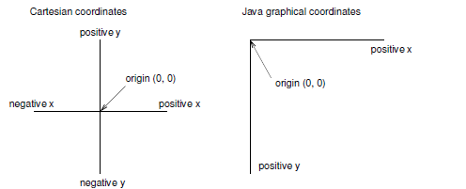

-Coordinates are measured in pixels, each pixel is a dot on the screen

-Coordinates are always integers

A.4 Color

-To choose color, you must invoke the setColor method on the Graphics object

g.setColor(Color.red)

-Color.red is provided by the color class, to use it you must import java.awt.Color

-Documentation on colors here: http://download.oracle.com/javase/6/docs/api/java/awt/

Color.html.

-You can control the background color of the Canvas by invoking Canvas.setBackground

A.5 Mickey Mouse

Sample code:

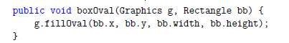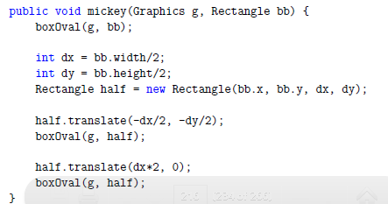

-The boxOval method takes the Graphics and Rectangle objects as parameters, and fills an oval with dimentions specified by the rectangle.

-The first line of mickey draws the face, the next three lines create smaller rectangles for the ears

-We translate the rectangle up and to the left for the first ear, and to the right for the second

The result:

Temporary Note: This code doesn’t work and I don’t have enough knowledge to know why, I’ll come back later to fix it once I know more about graphics and object-oriented programming.

I’ll also look at the GridWorld case study later, since it covers a lot of stuff I don’t know about yet.

11. Create your own Objects

11.1 Class definitions and object types

-Most important ideas in this chapter:

-Defining new class also creates a new object type with the same name

-A class definition is like a template for objects, it determines what instance variables the objects have and what methods can operate on them.

-Every object belongs to some object type, that is, it is an instance of some class

-When you invoke new to create an object, Java invokes a special method called a **constructor** to initialize the instance variables. You provide one or more constructors as part of the class definition

-The methods that operate on a type are defined to the class definition for that type

-Syntax issues with class definitions:

-Class names (and hence object names) should begin with a capital letter, since they are not primitive.

-You usually put one class definition in each file, and the name of the file must be the same as the name of the class.

-In any program, one class is designated as the startup class. The startup class must contain main, other classes may have a method named main, but it will not be executed.

11.2 Time

-A common reason for making an object type is to encapsulate related data in an object that can be treated as a single unit. Point and Rectangle for example

-Another example, which we will implement is Time. Which represents the time of day. The encapsulated data being the hour, minute and seconds, which will be the instance variables

-Instance variables are declared at the beginning of the class definition, outside of any method definition. Like so:

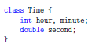

11.3 Constructors

Constructors intitialize instance variables.

-The systax for constructors is similar to that of other methods, with three exceptions:

-The name of the constructor is the same as the class

-Constructors have no return type and no return value

-The keyword static is ommited.

Example:

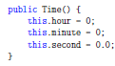

-Where you would expect to see a return type, there is nothing. This is how the compiler knows this is a constructor

-The name this. Is a keyword that refers to the object we are creating. You can use it the same way you would use the name of any other object.

-However you do not declare this. Nor do you make an assignment to it. this. Is created by the system all you have to do is initialize its instance variables.

-A common error when writing constructors is to put a return statement at the end, remember, they are NOT methods.

11.4 More Constructors

-Constructors can be overloaded like methods, which means you can provide multiple constructors with different parameters

-Java knows which constructor to invoke by matching the arguments of new with the with the parameters of the constructors

-It is common to have one constructor that takes no arguments (like Time) and one constructor with the same name that takes a parameter list. This provides the flexibility to create an object first and then fill in the blanks, or to collect all the information before creating the object.

11.5 Creating a new object

-Although constructors look like methods, you don’t invoke them directly.

-When you invoke new, the system makes space for the new object, then invokes the constructor.

-This program shows two ways to create and initialize Time objects.

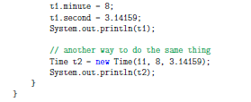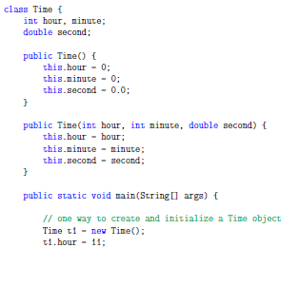

-In main, the first time new is invoked, we provide no arguments, so Java invokes the first constructor.

-The next few lines assign values to the instance variables

-The second time, we pass arguments that match the parameters of the second constructor, so it is invoked instead, and initializes the instance variables to those arguments.

-The second way is more efficient, but not as clear to read

11.6 Printing objects

The ouput of the program from 11.5 is:

Time@80cc7c0

Time @80ccB07

-When Java prints the value of a user defined object type, it prints the name of the type, and a special hexadecimal (base16) code that is unique for each object.This code doesn’t tell us anything specific, but can be useful in debugging.

-To print objects, write a method that prints each instance variable:

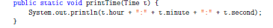

11.7 Operations on Objects

-There are three kinds of methods that can operate on objects:

1.) **pure function**: Takes objects as arguments and doesn’t modify them. The return values is either a primitive or a new object created inside the method.

2.) **modifier**: Takes objects as arguments and modifies some or all of them. Often returns void.

3.)**fill-in method**: One of the arguments is an “empty” object that gets filled in by the method. Technically, it’s a type of modifier.

-Its possible to write a given method as any of the above, each with their own pros and cons.

11.8 Pure Functions

-The only result of invoking a pure function is the return value.

-This method compares two Times and returns a boolean indicating whether the first operand comes after the second.

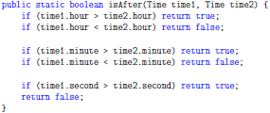

-The arguments are objects, and the return is a boolean, and the objects are not modified.

-This method returns an object created inside the method.

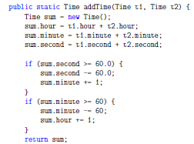

11.9 Modifiers:

As an example of a modifier, consider this method:

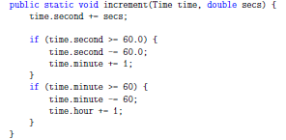

The first line does the operation, the rest deals with the cases where they are larger than 60 so it carries over.

However, if its much larger than 60, its still not sufficient to subtract 60 once, so:

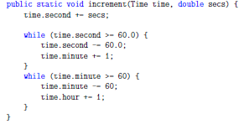

This loops until it’s a happy number of seconds.

This method is void, and serves only to change the instance variables of Time by an increment of secs.

11.10 Fill-in Methods

-Instead of creating a new object everytime *addTime* is invoked, we could require the caller to provide an object where *addTime* stores the result.

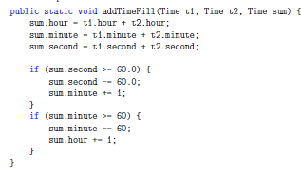

Instead of only the instance variables, this method takes an object argument, *sum*, where the result will be stored. This makes it so that the object *sum* is being modified, or “filled-in” by *addTimeFill*, and doesn’t need to make a new object each time *addTime* is invoked.

Modifiers and fill-in methods are efficient because they don’t have to create new objects, but make it difficult to isolate parts of a program, and can make debugging difficult

Pure functions help manage the complexity of large projects, by making certain errors impossible.

Also, its possible to speed them up by storing previously computed results since they depend only on the parameters.

Its reccommended to write pure functions whenever possible, and resort to modifiers only if there is a strong advantage.

11.11 Incremental development and planning

Rapid prototyping is the process of writing a rough draft that performs the basic calculation, then test a few cases, and correcting flaws found in them.

While effective, this approach can lead to messy, unneccessarily complicated code that is probably quite unreliable.

-An alternative is to look for insight in the problem that may make programming easier.

-Turns out, its we could use the fact that Time is really a three digit number in base 60

-The seconds are the ones column, the minutes are the 60’s column and the hour is the 3600 column

11.12 Generalization

-While base conversion in more abstract and kind of hard to deal with, its more general.

-The result is a shorter, more elegant and reliable program

-Basically, making the problem harder (more general) can make it easier(less special cases, more reliable, easier to add features etc)

11.13 Algorithms

-Algorithm is a general solution for a class of problems

-Contrary, a specific solution to a single problem is not an algorithm

-Algorithms do not require intelligence to carry out, you just follow steps

-Some simple things like language are almost impossible to express as an algorithm

**Here is where the book overlaps back to the lectures, so you can either skip forward to the rest of the lectures, or continue following the book.**

Chapter 12: Arrays

-An array is a set of values where each value is identified by an index

-Arrays look like other types, but followed by []

-Until you initialize these variables, they are null

-to create an array, use new: int [] count = new int[size], where size is the number of entries you want to have.

12.1 Accessing elements

-To store values, use the [] operator.

-Arrays start at index 0

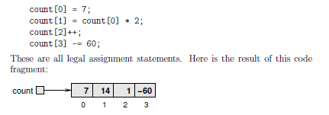-Example:

-If you get out of bounds of the array, you’ll get an ArrayOutOfBoundsException

-It’s common to index an array with a loop variable

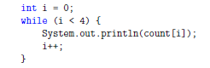-Example:

12.2 Copying arrays

-Remember that when you copy an array variable you’re copying a reference to the array

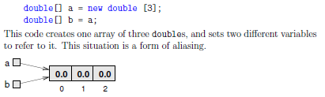

-Any changes to one array will be reflected in the other.

-This isn’t usually what you want, usually you’d want to make a new array and copy the elements over like this:

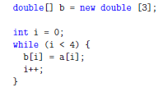

12.3 Arrays and objects

-Arrays and objects are similar in many ways

-When you declare an array, you get a reference to an array

-You have to use new to create the array itself

-When you pass an array as an argument, you pass a reference, which means that the method can change the contents of the array

-The key difference is that arrays are defined by their indices, while elements of objects have names

-Elements of an array must have the same type, while objects can have anything

12.4 For loops

-Covered before

12.5 Array length

-All arrays have one named instance variable. length. Its useful to use as an upper bound in a loop so that if the length changes, you wont get an error for out of bounds

12.6 Random numbers

-A **nondeterministic** program turns out to be very difficult but there are ways to make it seem non-deterministic.

-Java provides a method that generates **pseudorandom** numbers

-Math.random() returns a double between 0.0 and 1.0.

12.7 Array of random numbers

-How would you generate a random number between two bounds?

-One way to test how random things are, you could generate a long series of random numbers, store them in an array, and see how many times each appears. If it’s working, it should be approximately the same for each number

Example of an array being generated:

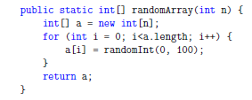

Example of printing this array:

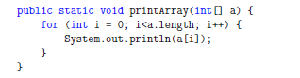

12.8 Counting

-Here we’ll use bottom-up development to create a histogram of some random numbers

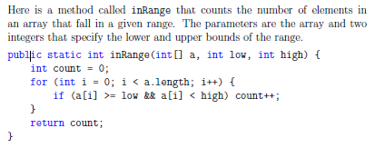

Now you can count the number of numbers in the ranges you’re interested in by calling this method for each range.

12.9 The histogram

-Say you wanted to keep track of a loot of ranges, how would you do that?

-Initialize an array outside the loop, then have a loop invoke inRange repeatedly to store each value

12.10 A single pass solution

-That way isn’t very efficient because it passes the original array many times

-It would be more efficient to make a single pass, and for each value, figure out which range it falls in

Chapter 13: Arrays of Objects

13.1 The Road Ahead

-Basically the next few chapters develop programs to work with playing cards and decks of cards

-This chapter defines a Card class and writes methods that work with Cards and arrays of Cards

-Next chapter will create a Deck class and white methods that operate on Decks

-Chapter 15 will be object-oriented programming (OOP) and will transform Card and Deck classes into a more OOP style.

-The code for this chapter can be found here: http://thinkapjava.com/code/Card1.java.

13.2 Card objects

-52 Cards in a deck, 4 suits, 13 ranks

-If we’re making an object called Card, it makes sense that the instance variables are rank and suit

-Its not obvious however, what type these variables should be.

-We could encode the ranks and suits with integers.ie:

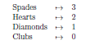

13.3 The printCard method

-When you create a new class, step one is to declare instance variables

-Next is to write the standard methods that every object should have, including one that prints the object, and one or two that compare the objects.

-To print Card objects in a way that humans can read easily, we want to map an integer code to words. A natural way to do that is with an array of Strings.

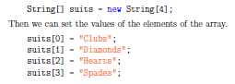

-Or, in a faster way:

-Remember that the elements of the array are references to the Strings, not Strings themselves

-Now we need another array of Strings to decode the ranks:

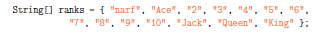

-Narf is just a placeholder for the 0th index of the array which shouldn’t ever be used.

-So the method would look like this.

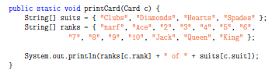

-This prints the element at the c.rank index of the rank array, and the element at the c.suit index of the suit array.

13.4 The sameCard method

-If we say two Cards are the same, does it mean they have the same rank and suit? Or are they the same Object

-Refences to the same object are **identical** while references to an object with the same data are **equivalent.**

-To check equivalence, its common to use a method like this:

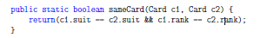

-When you compare Strings using == (which is ill-advised) you’re checking identity, not equivalence.

13.5 The compareCard method

-To compare objects you have to write a method that does it, cause you can’t use the operators like you would for primitive types, nor can you use the compareTo method that works for Strings.

-In Java, you cannot compare boolean types to see which is greater, because they’re unordered. Is true greater than false? I dunno

-Decks of cards are partially ordered, because you can’t know whats more important when it comes to suits.

-Since, by convention, when you buy a deck of cards, all the Clubs are together, Diamonds etc. We’ll say that suit is more important than rank

-compareCard will take two cards as parameters and return 1 if the first card wins, -1 if the second card wins, and 0 if they are equivalent.

13.6 Arrays of Cards

-You can make arrays of objects, but remember that they make references to the objects, it doesn’t contain the Card objects

-if you try to access the instance variables of non-existent cards, you’ll get a NullPointerException

-The easiest way to populate the deck with Card objects is to write nested for loops

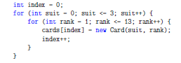

-The outer loop enumerates through the suits, the inner loop assigns a rank to each card of the suit before proceeding to the next suit.

18.7 The printDeck method

-When you work with array, it can be useful to have a method that prints its contents

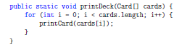

13.8 Searching

-The next method is called findCard, which searches an array of cards to see whether it contains a certain card. This method demonstrates **linear search**, and **bisection search**

**-** As soon as it finds the card the search stops, and when the loop finishes it knows the card isnt there

-It works great for when the deck is out of order, but theres a faster way when its in order

- When you look through a dictionary you probably:

1.) open it somewhere in the middle

2.)look at a word and compare to the word you’re looking for

3.)If you find the word you’re lookng for, stop

4.) If the word you’re looking for comes after the word on the page, flip to somewhere later in the dictionary and start again

5.)If the word you’re looking for comes before the word on the page, flip to somewhere earlier in the dictionary and go start again.

- If you get to a point where there are two adjacent words and your word is supposed to come between them, but its not, then your word is not in the dictionary

-If you know the cards are in order, then you can search this way.

-The best way to do it is to write a recursive method, because bisection is naturally recursive.

-The method will be called findBisect, and will take two indices as parameters, low and high

1.) To search the array, choose an index between low and high(call it mid) and compare to the card you’re looking for

2.) If you found it, stop

3.) If the card at mid is higher than your card, search the range from low to mid-1

4.) If the card at mid is lower than your card, search the range from mid+1 to high

Here it is in Java:

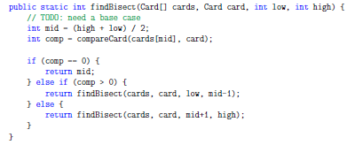

-The base case is when the card is not in the deck, so for this method as-is, it will go forever if the base case is true.

-If high>low, that is, the method ran until mid+1 went higher than high since the case where the card does not exist is considered an “else”, then it should return -1 to consider this case.

-Common errors in recursive programming are forgetting to include the base case, and writing the recursive call such that the base case is never reached, both will result in a StackOverflowException

13.9 Decks and subdecks

-We can think of cards, high and low as a single parameter that specifies a subdeck.

-This way is common, and sometimes called an **abstract parameter**

-This kind of thinking is important as a computer scientist. A program which takes on meaning beyond what is literally encoded. **Abstraction** is a central idea in computer science

-A more general definition of abstaction: “The process of modelling a complex system with a simplified description to suppress unnecessary details while capturing relevant behavior.”

Chapter 14: Objects of Arrays

WARNING: In this chapter, it’s another step toward Object-oriented programming, but we aren’t there quite yet. Many of the examples just arent good in Java. Its more to help learn some concepts. DO NOT WRITE ACTUAL CODE LIKE THIS

14.1 The Deck class

-In this chapter we create a Deck object that contains an array of Cards.

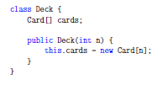-Here is the Class definition:

-This initializes the instance variable with an array of cards, but doesn’t make any cards.

-Here is a constructor that makes a 52 card deck and populates it with Cards:

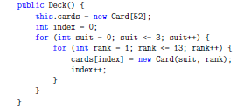

-Its similar to makeDeck method from before, but instead its written as a constructor

-To invoke it, use new

-Deck deck = new Deck();

-It makes sense to put methods pertinent to Decks in the Deck class, an obvious candidate is the printDeck method

-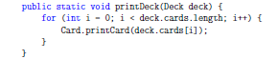

The method has been modified to work with a Deck object. Note the key differences:

-We cannot use deck.length, because deck is not an array, it is an object containing an array as an instance variable. So we need to specify which instance variable we want to find the length of. For that same reason, to access an element of that array, we must use deck.cards[i]

-We also cannot directly print the deck, since we need a method that can print an array, for this we invoke the printCard method from the Card class we defined last chapter.

14.2 Shuffling

-A good shuffling algorithm could be to traverse the deck one card at a time, and at each iteration, swap two cards.

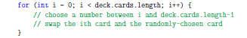-**pseudocode** explaining the proccess:

* The process of writing pseudocode, then writing methods that make it worth is called **top-down development.**

-We’ll need something like randomInt, which takes two indices and generates an integer between low and high, and swapCards, which takes two indices and swaps them.

-Heres what it looks like in code (I made this ☺ ):

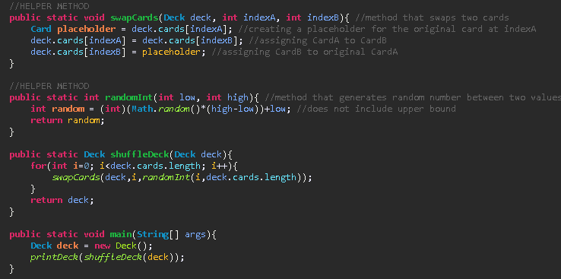

14.3 Sorting

-Now that we have a shuffled deck, it might be useful to put it back in order

- **selection sort** works by traversing the array repeatedly and selecting the lowest remaining card each time

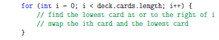-here’s the pseudocode:

-Heres what I wrote: 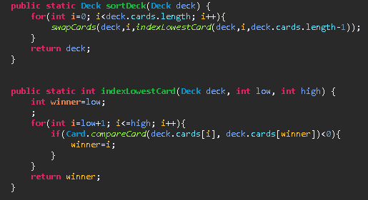

14.4 Subdecks

-If we create a new class called Hand, which might extend Deck, we can create a subset of deck.

-Or, we could represent a Hand as a deck of fewer than 52 cards

-We might want a method called subdeck, that takes a Deck and a range of indices, then returns a new Deck that contains those cards

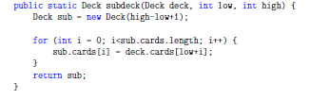

-The length of the subdeck is high-low+1 because both the low and high cards are included

-To avoid off-by-one errors, it can be useful to draw a picture

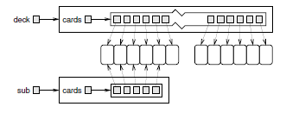-Because we pass an argument into the new Deck() command, we invoke the first constructor, not the second which would make a deck of length 52. The first constructor has variable length and doesn’t allocate any cards, hence the for loop

- State diagram:

-From the diagram you can see that there is a hand of 5 cards, and it shares the values of deck (aliasing), its safe to do that here because the ranks and suits of deck will never change

14.5 Shuffling and Dealing

-We can now use shuffleDeck and subdeck to deal hands.

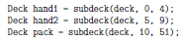

-First we shuffle the deck to randomize the order, then we deal three hands of 5 from the top, and store the remaining cards in the pack.

14.6 Mergesort

-The sorting method we used int 14.3 isnt very efficient, since we need to travese an array n times, and each time takes time proportional to n. So we’re taking time proportional to n2.

-A more efficient algorithm is **mergesort** which takes time proportional to nlog(n). It may not seem impressive, but as n gets big, the difference is tremendous

-If you have two subdecks, each has been sorted, its easy to merge them into a single sorted deck

-If you did this manually it would go something like this:

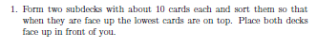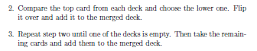

-Here it is in psuedocode:

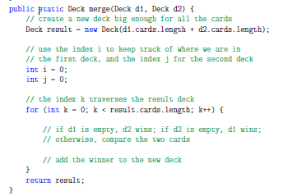

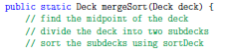

-Then if you get that working, the real fun begins, this method is recursive! So why invoke the old slow sorting, when you coiuld invoke the new mergeSort? Its actually needed to get the nlogn performance advantage.

-But to make that work you’d have to make a base case, which is easy here: when one of the subdecks hits 0 or 1 cards. If mergesort receives such a small subdeck, it can return it unmodified, since its already sorted.

-The recursive version of mergesortwould be something like this:

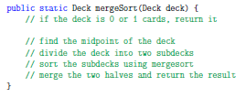

14.7 Class Variables

-So far we have seen local variables, which are declared inside a method, and instance variables, which are declared in a class definition.

-class variables are defined in a class definition before the methods, but they are identified by the keyword **static** They are created when the program starts and survive until the program ends.

-You can refer to a class variable from anywhere inside a class definition, and are often used for constants that are needed in several places.

Example:

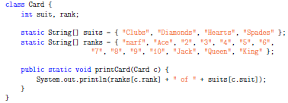

Chapter 15: Object-oriented programming

15.1 Programming languages and styles

-Styles are sometimes called paradigms.

-The programs we’ve written so far are **procedural**, because the emphasis has been on specifying computational procedures.

-Most Java programs are **object-oriented** meaning the focus is on objects and their interactions

-Objects often represent entities in the real world, example: the Deck object

-The majority of methods are object methods (like the methods you invoke on Strings) rather than class methods (like the Math methods). The methods we have written so far have been class methods, in this chapter we’ll write some object methods.

-Objects are isolated from eachother by limiting the ways they interact, especially by preventing them from accessing instance variables without invoking methods.

-Classes are organized in family trees where new classes extend existing classes, adding new methods and replacing others.

-In this chapter we translate the Card program into an object-oriented style.

15.2 Object methods and class methods

-Class methods are identified by the keyword static

-Although we have not written object methods, we have invoked some

-Anything can be written as either type of method, but sometimes its more natural to use one over the other

-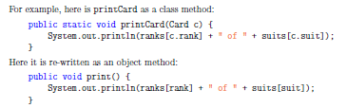

-The changes here are: removed static, changed name to be more idiomatic removed the parameter, and refer to the instance variables as if they were local variables.

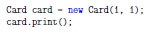-The method is now invoked like this:

-Look familiar? This is how we invoke the Math library!

15.3 The toString method

-Every object type has a method called toString which returns a string representation of the object.

-When you print an object using print or println, Java invokes the objects toString method

-The default version of toString returns a string that contains the type of the object and a unique identifier.

15.4 The equals method

-The == operator tests identity, but there is no operator that tests equivalence, because it depends on the type of the objects.

-There is a method called equals that defines equivalence

-For user defined types, the default behavior is the same as identity, which is usually not what you want

-We already wrote a method that checks equivalence:

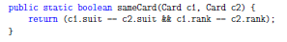

-So now all we have to do it rewrite it as an object method:

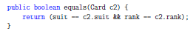

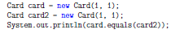-here is how its invoked:

-Inside equals, card is the current object and card2 is the parameter

15.5 Oddities and errors

-If you have object methods and class methods in the same class, it is easy to get confused.

-A common way to organize a class definition is to put all the constructors at the beginning

-Followed by object methods, then class methods

-You can have an object method with the same name as object methods

-Main is a class method

-if you get a message like: “non-static variable cannot be referenced from a static context” it usually means you didn’t provide the object name using dot notation

15.6 Inheritance

-inheritance is the ability to define a new class that is a modified version of an existing class

- sometimes the existing class is called the parent class, and the new class is called the child

-This allows you to add methods and instance variables without modifying the parent

-In the GridWorld sections, this is used.

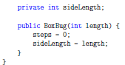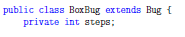

-BoxBug extends Bug means that BoxBug is a new kind of Bug that inherits the methods and instance variables of Bug. In addition, it gains steps and sideLength, gains a constructor.

-The child can override a method from the parent, in this case, the child provides act (not shown) which overrides the act method made from the parent.

15.7 The class hierarchy

-The most basic class is called Object. It contains no instance variables, but it provides the methods equals, toString etc.

-Many classes extend Object, including most of the classes we’ve written and many Java classes like java.awt.Rectangle.

-Any class that does not explicitly name a parent inherits from Object by default.

-Some inheritance chains are much longer

-Example: javax.swing.JFrame extends java.awt.Frame, which extends Window, which extends Container, which extends Component which extends Object.

-Object is the common ancestor

-The “family tree” is the class hierarchy.

15.8 Object-oriented design

-Some programs that would be too complicated without inheritance can be written simply using it.

-Inheritance can facilitate code reuse.

-Inheritance can make some programs hard to read however, when you see a method invocation, it can be hard to figure out which method gets invoked.

-Some things that can be done with inheritance are simply better done without it

-The alternative is **composition** where new objects are composed of existing objects

-Designing objects and the relationships among them is the definition of object-oriented design.

-Check out *Head First Design Patterns*  for more on that